**Triple carry avoidance**

P. Dasa, K. Kalimuthub, A. Sarkarc, S.A.R. Devaland, V.P. Dubeye, N. Aryanc, A.D. Chatterjeeg

a Department of Electronics & Communication Engineering, SRM Institute of Science and Technology, Kattankulathur, Tamil Nadu 603203, India.

b Department of Mechanical Engineering, SRM Institute of Science and Technology, Kattankulathur, Tamil Nadu 603203, India.

c Department of Computer Science and Engineering, SRM Institute of Science and Technology, Kattankulathur, Tamil Nadu 603203, India.

d Department of Electronics & Telecommunication Engineering, Jadavpur University, Kolkata, West Bengal 700032, India.

e Department of Computer Science and Engineering,Indian Institute of Engineering Science and Technology, Shibpur, Howrah, West Bengal 711103, India.

**Abstract**

In many states, the traffic signals have been upgraded into smarter solutions, but real-time surveillance and regulation of traffic rule offenders are yet to be seen. Triple carry is prohibited by law in our country, and yet the offense is rarely talked about and looked upon by the traffic police. It is not only illegal but also risky and dangerous for multiple people. The motorcycle driver along with two riders pose risk to their own lives as well as that of other people. This is because when a motorcycle that is meant to carry two people gets a load of three, it loses its structural balance and the suspension poses a risk of damage. This phenomenon is widely seen in small localities where people need not travel long distances. Such a place where we tried to bring smarter surveillance and regulation was our university campus in Tamil Nadu, India.

**Acknowledgement**

Our team would like to express our gratitude to SRM Institute of Science and Technology for the support and guidance. Our team would further express our gratitude to Dr K. Kalimuthu, for the time, knowledge and constant encouragement she has lent us for making this project. We express our special thanks to Dr. C.T. Manimegalai and Dr. Sabitha Gauni for their diligent guidance and for their support during our research work.

**Introduction**

The university provides guards present at the entry gate to the campus for identity verification, for safety standards like checking body temperature for covid, wearing a helmet when you are on a two-wheeler, and checking whether there is any triplet on the bike before entering the campus. But it is generally outside the campus at the gates where one can get access for checking for triple carry and not inside the campus as it is not possible for guards to check at each and every turn inside the large area of the campus. So in most of the cases, for students who carry a third person on their bikes outside the campus, when they reach near the checking point on the gate, they drop one and enter successfully without scrutiny carrying the other person in their bikes. On the other hand, the other rider enters the campus on foot and again gets up on the bike, resulting in a triple carry. Thus, checking near the entrance gate is not efficient when it comes to curbing triple carry.

**Design and Specification**

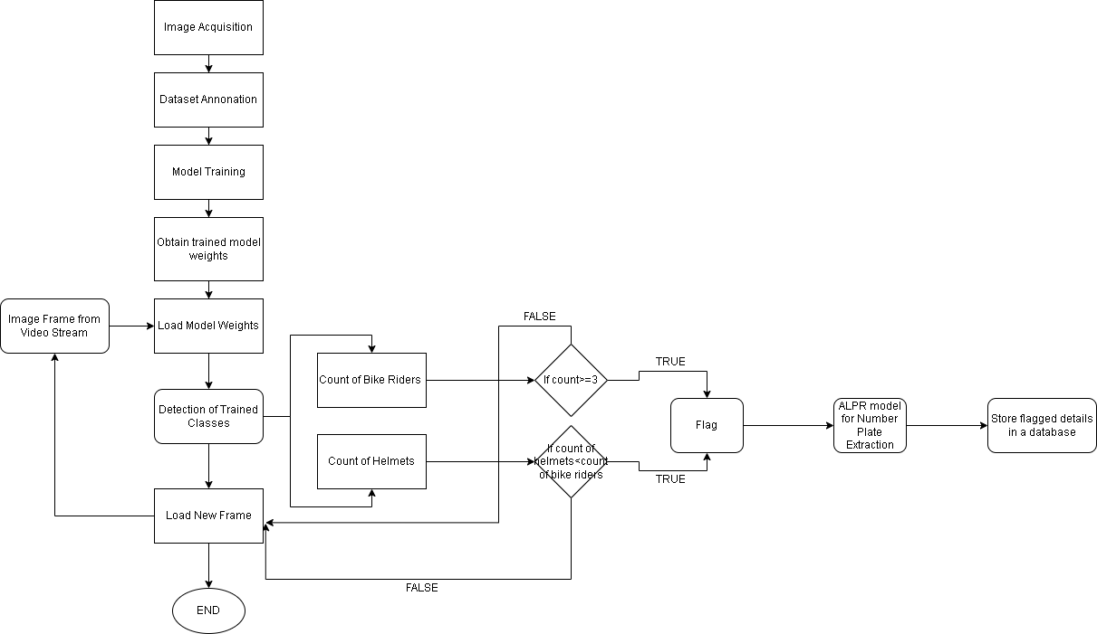

*Fig. 1: Algorithm to detect violation using image processing and to store the details into database*

**Methodology**

Object detection is the craft of detecting instances of a certain class, like animals, humans and many more in an image or video. The Pre-Existing Object Detection API makes it easy to detect objects by using pre-trained object detection models. But these models detect several objects which are of no use to us, therefore in order to detect the necessary classes, a custom object detector becomes necessary. (refer)

Object detection alludes to the ability of computer and programming frameworks to find objects in a picture/scene and recognize each article. Object detection has been broadly utilized for face detection, vehicle detection, pedestrian, web pictures, security frameworks, and driverless vehicles. Numerous ways of object detection can be utilized too in many fields of training. Like every other computer innovation, a wide scope of imaginative and astounding employments of object detection will come from the endeavors of computer software engineers and programming designers.

The forward leap and quick reception of deep learning in 2012 brought into reality the present day and exceptionally precise object detection calculations and techniques, for example, R-CNN, Fast-RCNN, Faster-RCNN, RetinaNet, and quick yet profoundly exact ones like SSD and YOLO. Utilizing these techniques and calculations, in light of deep learning which is additionally founded on AI requires loads of numerical and deep learning systems understanding. There are a huge number of master software engineers and programming designers that need to coordinate and make new items that utilize object detection. However, this innovation is kept out of their hands because of the extra and complicated way to understand and utilize it.

In order to implement helmet detection and number plate recognition and extraction, a multitude of objects need to be detected and some of them counted. The objects are – Motorbike, Helmet (Count of the Helmets), People on the Bike (Count of the People) and License Plate. (refer)

Numerous scientists have additionally proposed a strategy that includes the detection of motorcyclists, trailed by checking whether or not the motorcyclist wears a protective cap. For the detection of moving objects, the creators have proposed a foundation deduction technique to remove the moving object and arrange them by separating highlights utilizing Local Binary Pattern (LBP). In the wake of getting the motorbike, the 1/5 of the picture from the top was edited to get the cap area and characterized it utilizing HOG, Hough Transform, and LBP descriptors.

*Particular Approach*

Case 1: Person Detection and Counting

Our first YOLOv3 model is trained on data consisting of images annotated with bounding boxes around motorcycles. Once the model detects the motorcycles the entire area bound is cropped using OpenCV so that it can be processed further to detect the number of people riding it and the number of people wearing helmets.

Case 2: Helmet Detection and Counting vs No. of Riders

A combination of object tracking and object detection in a single algorithm must be used to accurately detect triple carry. Using OpenCV the number of people entering the frame of a CCTV camera can be counted.

For the detection of moving objects, the creators have proposed a foundation deduction technique to remove the moving object and arrange them by separating highlights utilizing Local Binary Pattern (LBP). In the wake of getting the motorbike, the 1/5 of the picture from the top was edited to get the cap area and characterized it utilizing HOG, Hough Transform, and LBP descriptors.

If the number of people exceeds two, or the riders do not wear helmets, the image frames were sent for number plate detection.

Case 3: Number Plate Extraction and Storage for Flagged Users

Once it has been checked for triple riding on a two-wheeler in a single image frame, we need to extract the number plates of the vehicle. There are deep learning-based tools like EasyOCR and PyTesseract in Python that allows us to extract text from an image conveniently. EasyOCR performs very well on invoices, handwriting, car plates, and public signs. Even big tech companies have their own services like Google Vision, Microsoft Computer Vision APIs to extract the images.

One of the major drawbacks in this method is the quality of images. So, deep learning algorithms can be used to convert low-resolution images to high resolution images. RAISR, an algorithm released by Google, combines traditional upsampling with deep learning to change low-resolution images into high-resolution counterparts.

So, the images need to be converted to high resolution before being sent for text detection.

For customized applications, the digital image processor would be integrated onto a compact system on chip in the CCTV along with the central processing unit that would contain the program to extract the required data like number plate and send it to the centralized database.

The database server should be configured to send messages and emails directly to the number and e-mail ID associated with the offender's number plate when there is an update. This can be done by running an SQL query to retrieve the relevant information, which is then sent in the form of notice by putting the information in placeholders of a pre-written text message.

The CCTV camera is supposed to store visual data in digital format in its storage medium. The SoC would preferably also have an image sensing unit connected to the image sensor of the camera that would process the visual data received and accordingly adjust the focus and exposure to get the best possible result.

If and when a captured image is blurred, sharpening would be done on the image to reinforce the edges of the objects by performing a matrix-based calculation on the digital image.

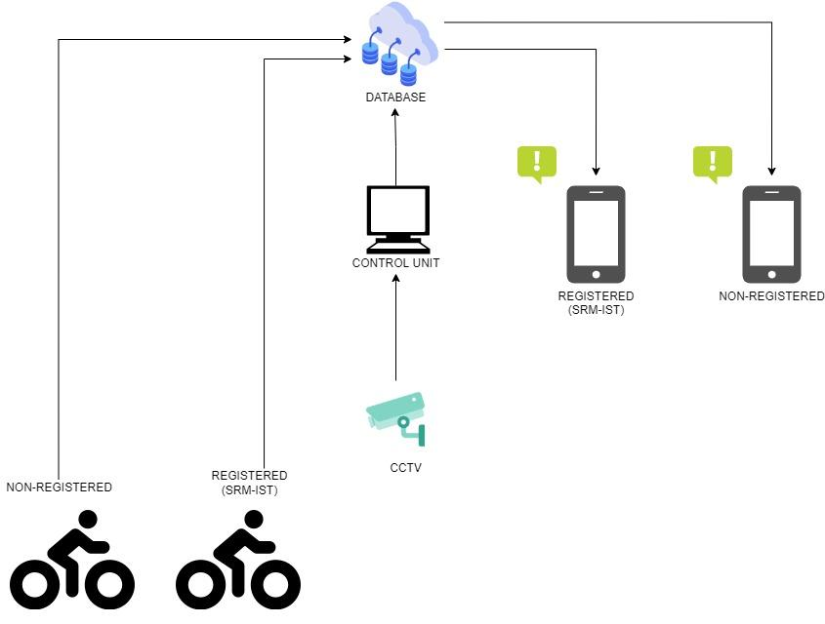

*Fig. 2: Overall system for detection and storage of violation*

**Result and Evaluation**

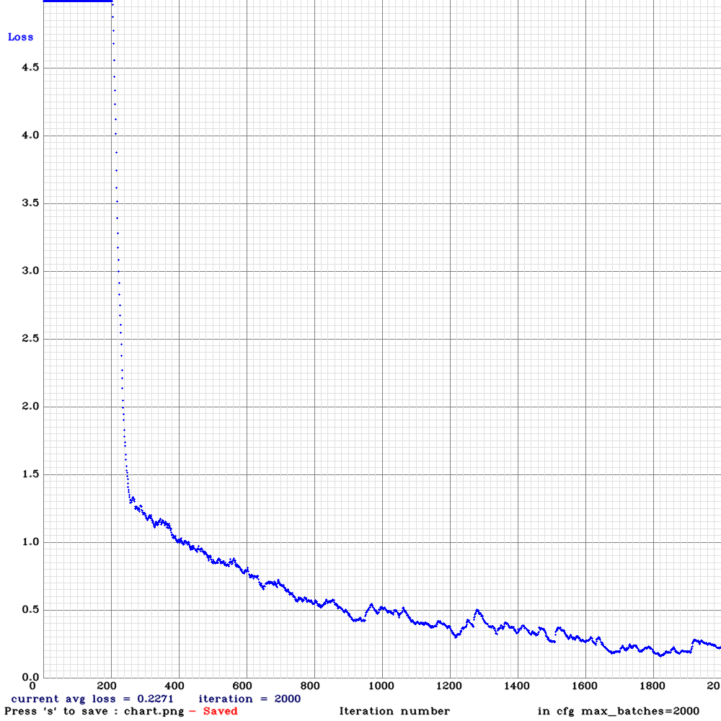

*Fig.3: Loss vs Iterations for Rider Detection Model*

The three YOLOv3 models were trained using Darknet, an object detection library written in C/C++. All models were converging after roughly 1500 epochs and standardized well to the given use cases. Training newer more improved models with manually annotated datasets specific to our target locations would yield a model more well-suited to our needs.

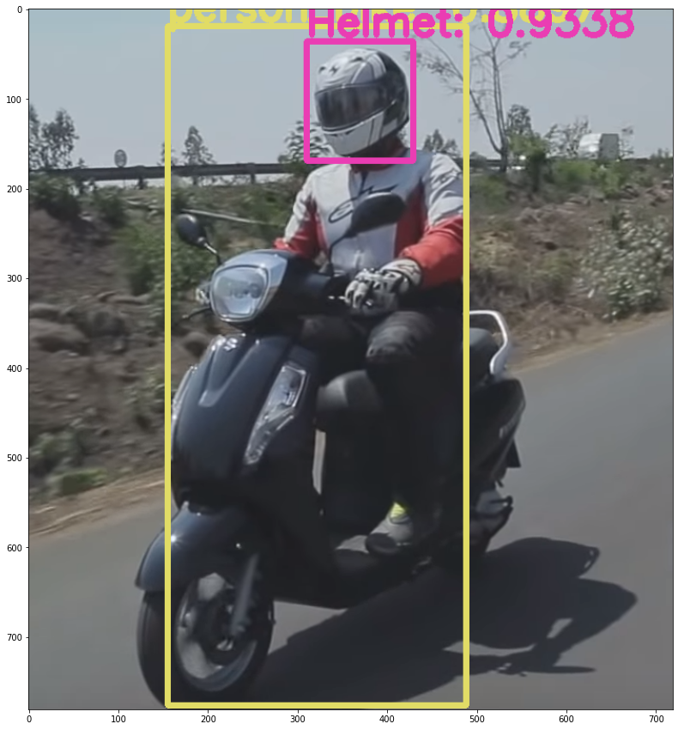

*Fig 4: Models in Use*

**Conclusion**

As mentioned, triple carry on two-wheelers has been made a punishable and fineable offense across the country and is being enforced strictly. This is due to various reasons ranging from personal to civic safety that is endangered by triple riding on a bike. This makes it all the more important to ensure that through technology we can help in better and more efficient enforcement of this law on our campus. Our technology can bring down the number of repeat offenders. This technology can also be applied throughout the country and potentially help in decreasing one of the major causes of bike or traffic accidents.

**Future work**

For customized applications, the digital image processor would be integrated onto a compact system on chip in the CCTV along with the central processing unit that would contain the program to extract the required data like number plate and send it to the centralized database.

The database server should be configured to send messages and emails directly to the number and e-mail ID associated with the offender's number plate when there is an update. This can be done by running an SQL query to retrieve the relevant information, which is then sent in the form of a notice by putting the information in placeholders of a pre-written text message.

The CCTV camera is supposed to store visual data in digital format in its storage medium. The SoC would preferably also have an image sensing unit connected to the image sensor of the camera that would process the visual data received and accordingly adjust the focus and exposure to get the best possible result.

If and when a captured image is blurred, sharpening would be done on the image to reinforce the edges of the objects by performing matrix-based calculation on the digital image.

**References**

1. [US20060098729A1 - Smart image processing CCTV camera device and method for operating same - Google Patents](https://patents.google.com/patent/US20060098729A1/en#patentCitations)
2. [India: triple riding prosecutions by Delhi traffic police 2020 | Statista](https://www.statista.com/statistics/1082087/india-triple-riding-prosecutions-delhi-traffic-police/)
3. [Mission Road Safety on Twitter: "Tripple riding is not only dangerous for whoever rides but also to the other people around them. Don](https://twitter.com/missionroadsafe/status/1156759515238244354)[•](https://www.statista.com/statistics/1082087/india-triple-riding-prosecutions-delhi-traffic-police/) ['t indulge in tripple riding or over loading on two wheeler](https://twitter.com/missionroadsafe/status/1156759515238244354)s
4. [SRM Institute of Science and Technology releases engineering rank list | The News Minute](https://www.thenewsminute.com/article/srm-institute-science-and-technology-releases-engineering-rank-list-130496)
5. [Stanley focuses on the future of remote monitoring | SecurityWorldMarket.com](https://www.securityworldmarket.com/int/News/Business-News/stanley-focuses-on-the-future-of-remote-monitoring)
6. [IRJET-V6I1214.pdf](https://www.irjet.net/archives/V6/i12/IRJET-V6I1214.pdf)
7. [(PDF) Smart Surveillance System for Automatic Detection of License Plate Number of Motorcyclists without Helmet (researchgate.net)](https://www.researchgate.net/publication/325777319_Smart_Surveillance_System_for_Automatic_Detection_of_License_Plate_Number_of_Motorcyclists_without_Helmet)
8. [(PDF) Detection of Non-Helmet Riders and Extraction of License Plate Number using Yolo v2 and OCR Method (researchgate.net)](https://www.researchgate.net/publication/338124157_Detection_of_Non-Helmet_Riders_and_Extraction_of_License_Plate_Number_using_Yolo_v2_and_OCR_Method)
9. [conf_7.pdf (iith.ac.in)](https://www.iith.ac.in/~ckm/pdfs/conf_7.pdf)